Sir David Attenborough’s 100th Birthday Assembly Script
Script | Slide
Slide one: Title Slide | Slide one:  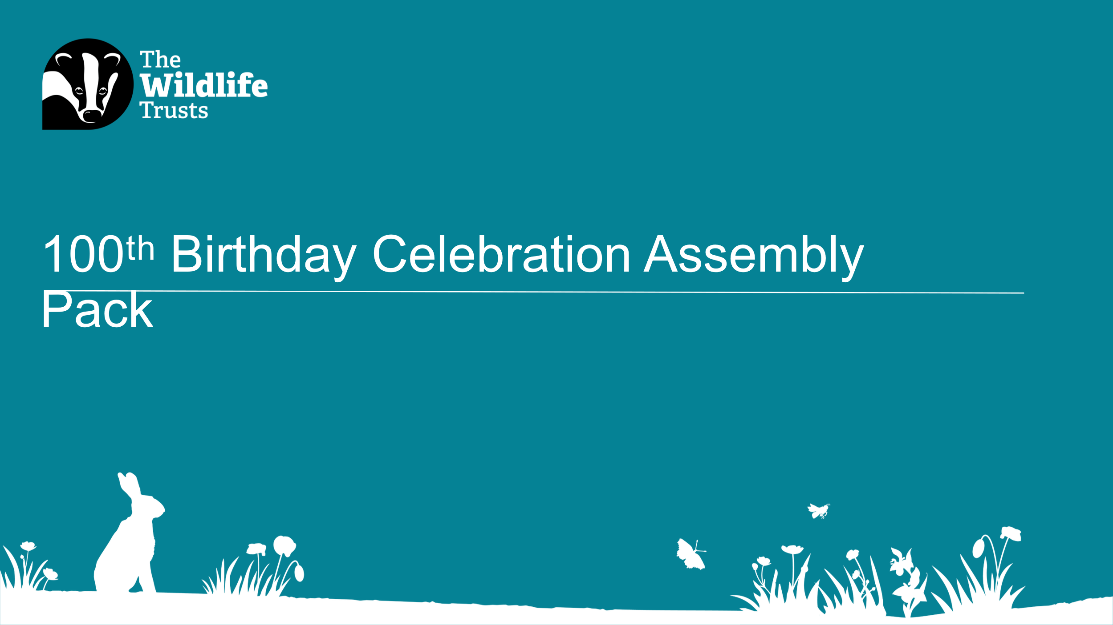
Slide two (instructional slide only) | Slide two:  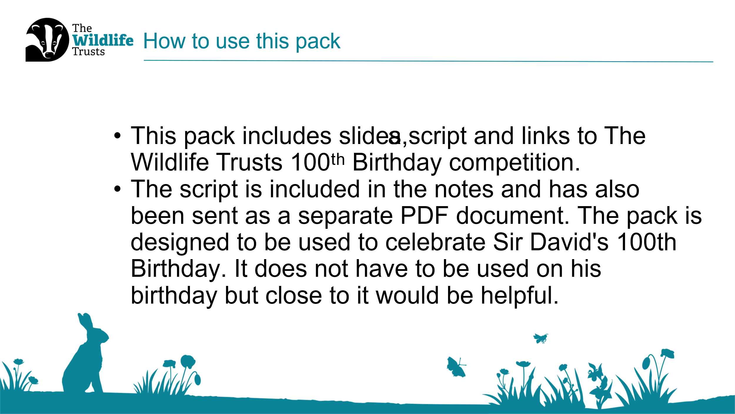
Slide three: Opening & Introduction  [Show slide while pupils enter the hall. You may wish to play suitable welcome music.]  Script: We are gathered here today to celebrate the 100th birthday of someone very special — not just to the UK, but to the whole world. I wonder who it might be? Take a quiet moment to think about whose 100th birthday has been celebrated recently.  [Pause to allow pupils time to think.]  Would anyone like to share who they think it might be?  [Listen to pupils’ suggestions but do not confirm any answers yet.]  Those are some great ideas. Let’s look at some clues to see if we’re getting closer. | Slide three:  
Slide four: Guess Who? Clues  Script: Clue number one — this person is a naturalist.  Does anyone know what a naturalist is?  [Take responses and confirm meaning.]  Are we any closer to guessing who it might be?  Clue number two — they are famous for making television documentaries.  Can anyone tell me what a television documentary is?  [Take responses.]  So, we’re thinking of someone who is a naturalist, makes TV documentaries, and is turning 100.  If you think you know, put your hand up — but don’t say the name just yet!  Let’s look at some more clues.  They love exploring different countries and make programmes about wildlife and plants all over the world.  And our final clue…  They encourage people to make positive changes to help the natural world.  Turn to the person next to you and quietly whisper who you think it might be.  [Allow brief discussion.]  Let’s find out if we were right.  [Optional drum roll by tapping hands on knees.] | Slide four:  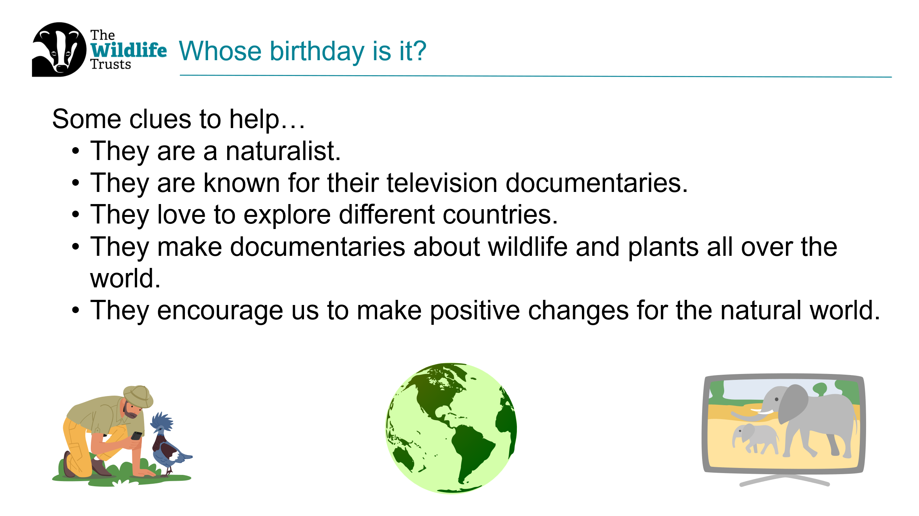
Slide five: Reveal  Script: You guessed correctly — it is Sir David Attenborough, who turned 100 on Friday 8th May 2026. How many of you have watched a David Attenborough documentary before?  Let’s watch a short clip now. You might recognise his voice, even if you don’t recognise the programme.  [Play an age appropriate clip.] | Slide five:  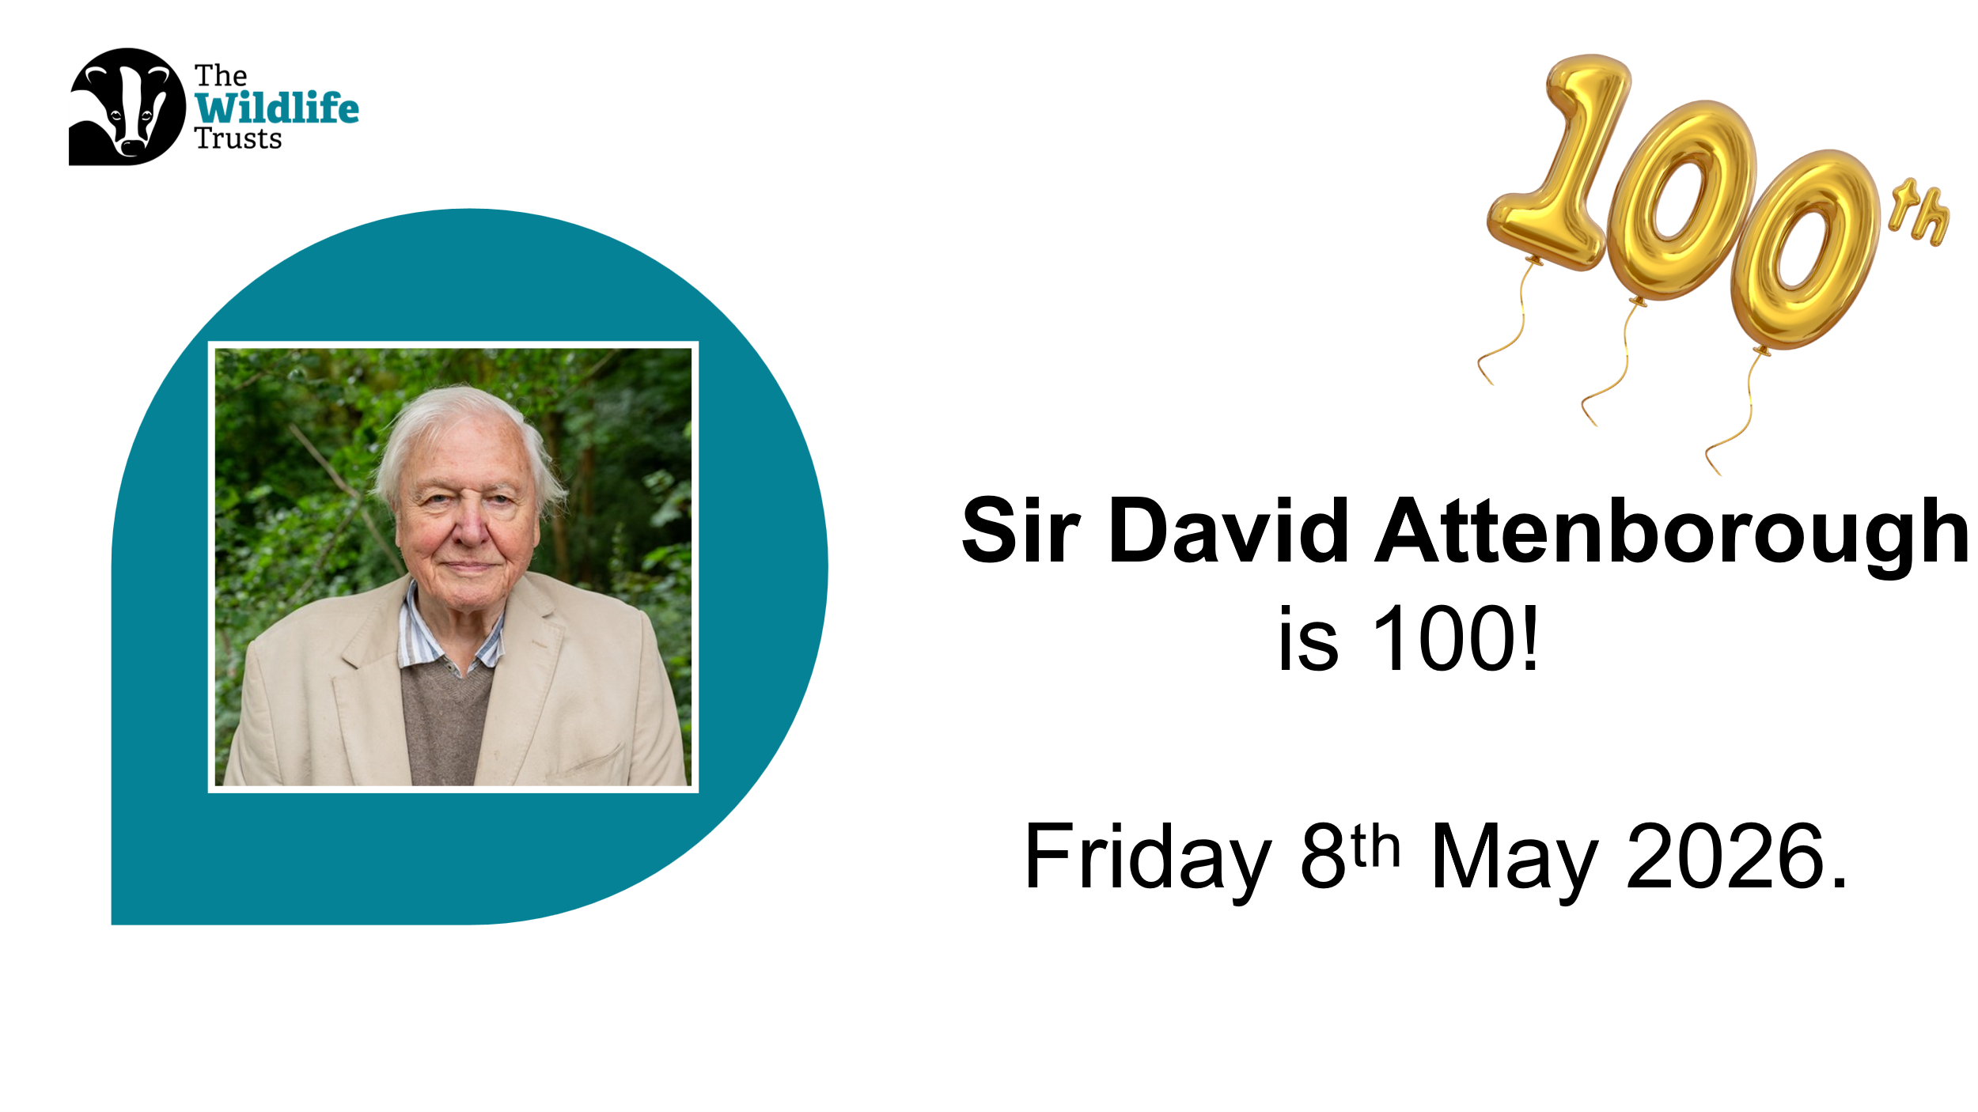
Slide six: What we will learn  Script: Today, we are learning about:  - The life and work of Sir David Attenborough  - Why his message about nature is so important  - The Wildlife Trusts Green Promise competition, created to celebrate his 100th birthday.  Our assembly also links to the values of wisdom, courage, and hope.  [Adapt values if needed.]  Sir David was born 100 years ago.  Can anyone work out what his date of birth would be?  [Take responses.] | Slide six:  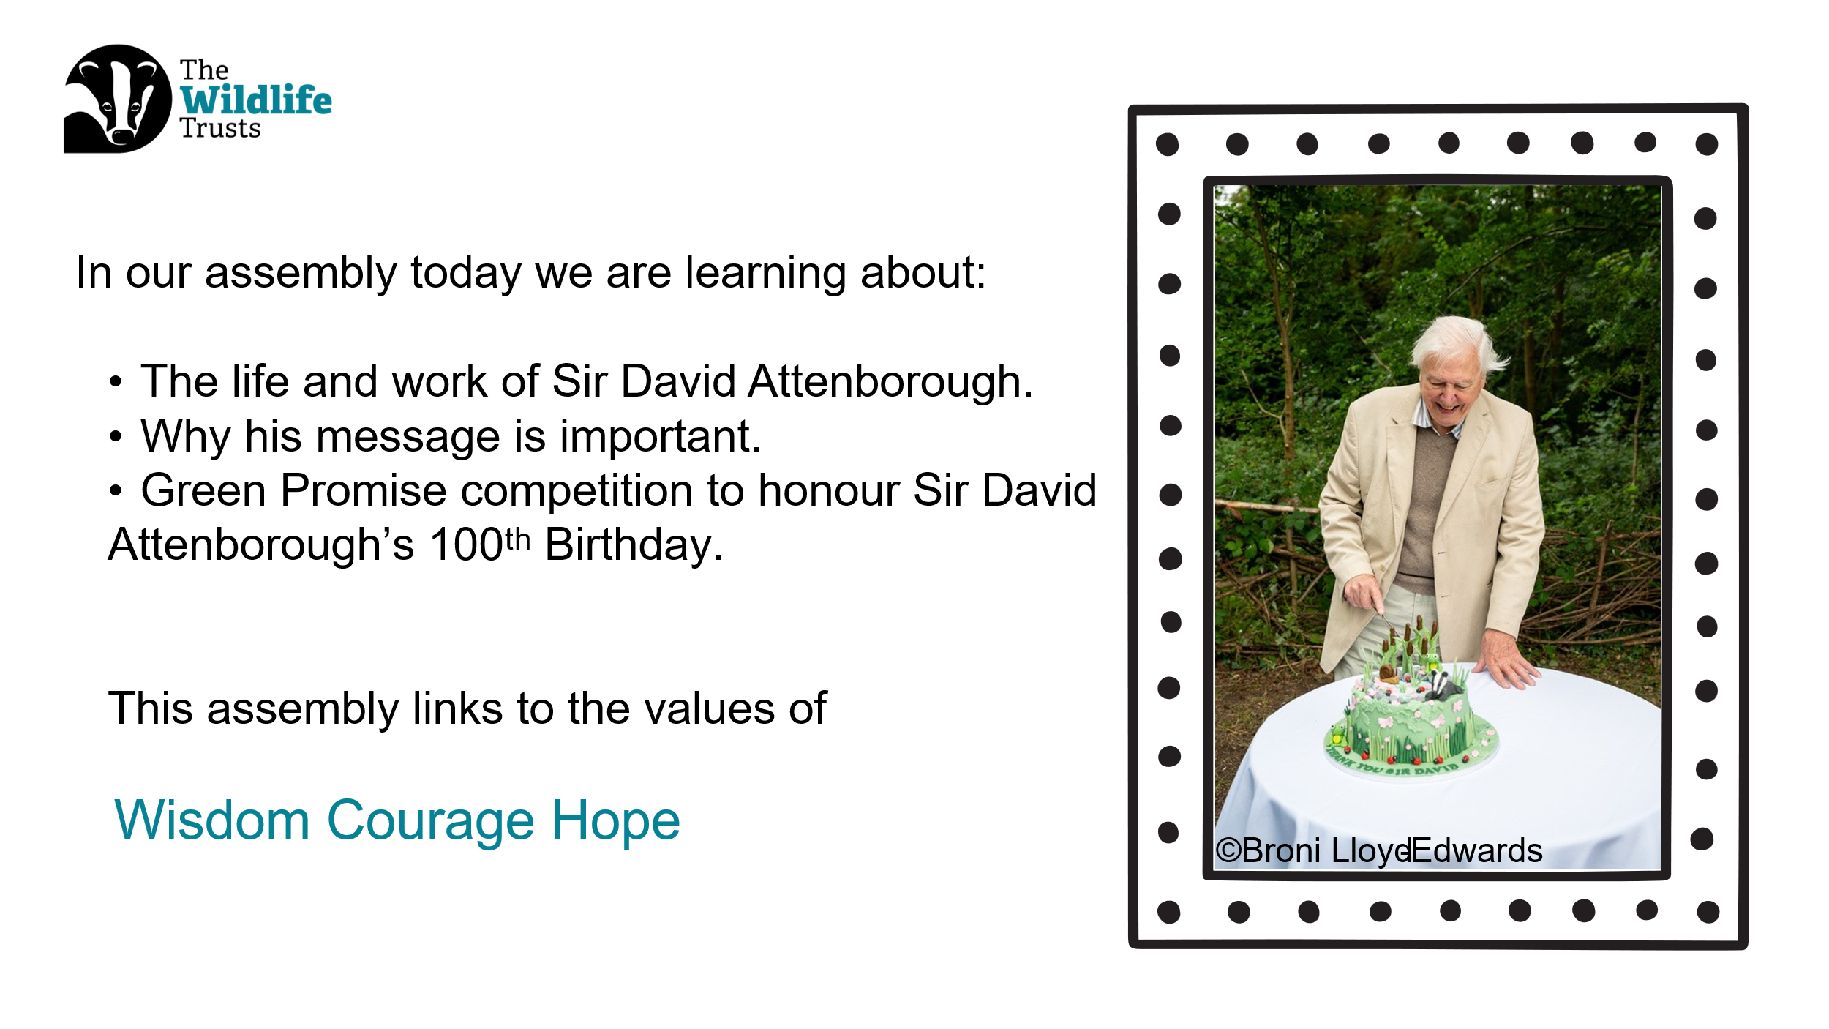
​Slide seven: Early Life & Curiosity  Script:  Sir David Attenborough was born in Isleworth, London. His mother was Mary, his father was Frederick, and he had two brothers — Richard and John.  When David was five, his family moved to Leicester, where his father worked at the university. The family lived on the university campus.  As a young boy, David loved to explore. He often rode into the countryside, looking at plants, animals, and hunting for fossils.  He even went pond dipping to find newts. The University of Leicester’s zoology department once paid him three pence per newt!  Fossil hunting was another passion. He used a hammer to break open rocks and often found ammonites. Does anyone know what an ammonite is?  An ammonite is an extinct sea creature, and we find fossils of their shells today. David loved thinking that he might be the first person to see that creature in millions of years.  All of these adventures helped grow his curiosity about the natural world. | Slide seven:  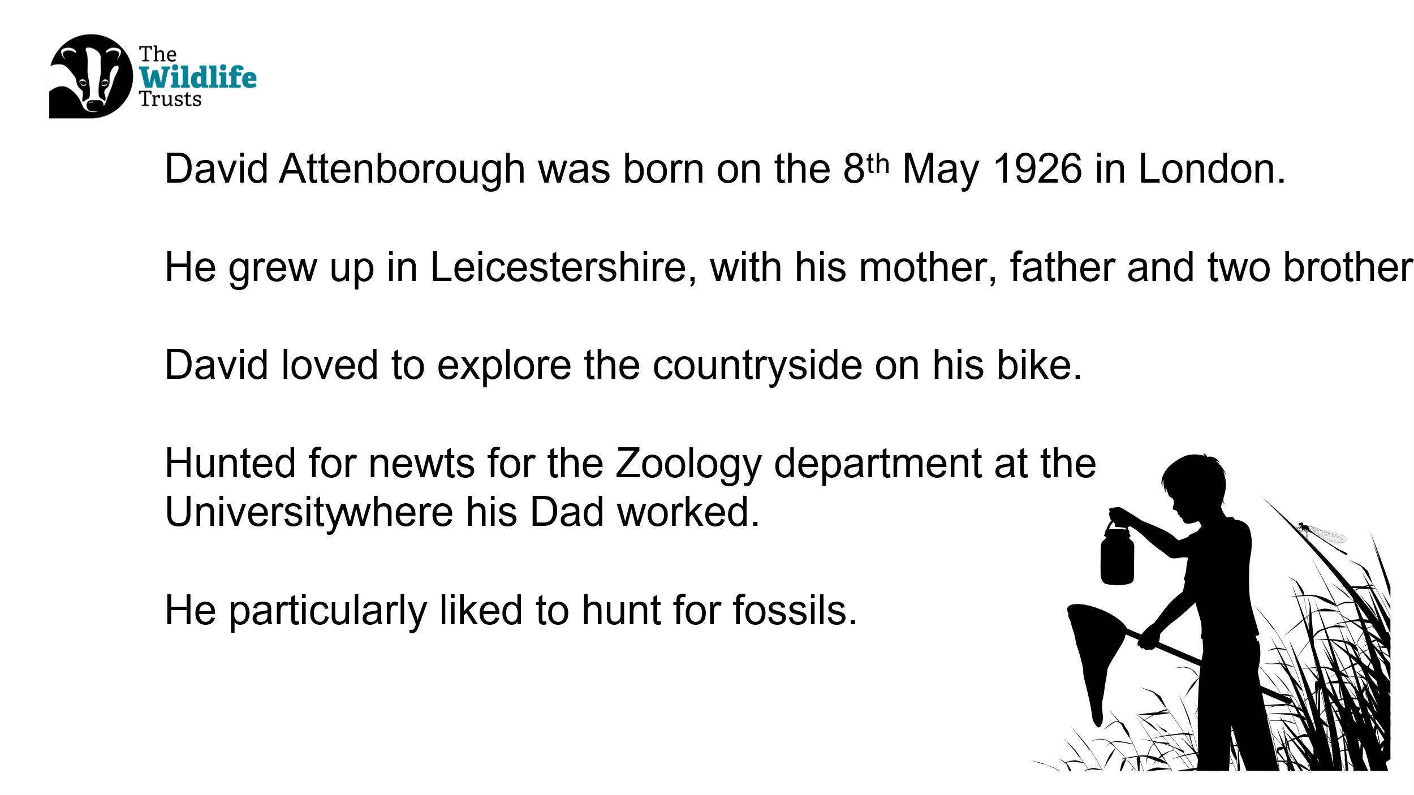
Slide eight: Career & impact  Script:  Sir David’s career has lasted over 70 years. He studied Natural Sciences at university and completed his national service in the Royal Navy. In the 1950s, he began working for the BBC, when television was only black and white. One of his first programmes was called Zoo Quest. Later, when television became colour, Sir David decided people should see animals in their natural habitats. That’s when he moved in front of the camera and began making wildlife documentaries.  He has now made over 100 documentaries, showing people animals and places they could only dream of seeing — from whales and penguins to gorillas and sloths.  Through his work, millions of people have learned to love and care about nature. | Slide eight:  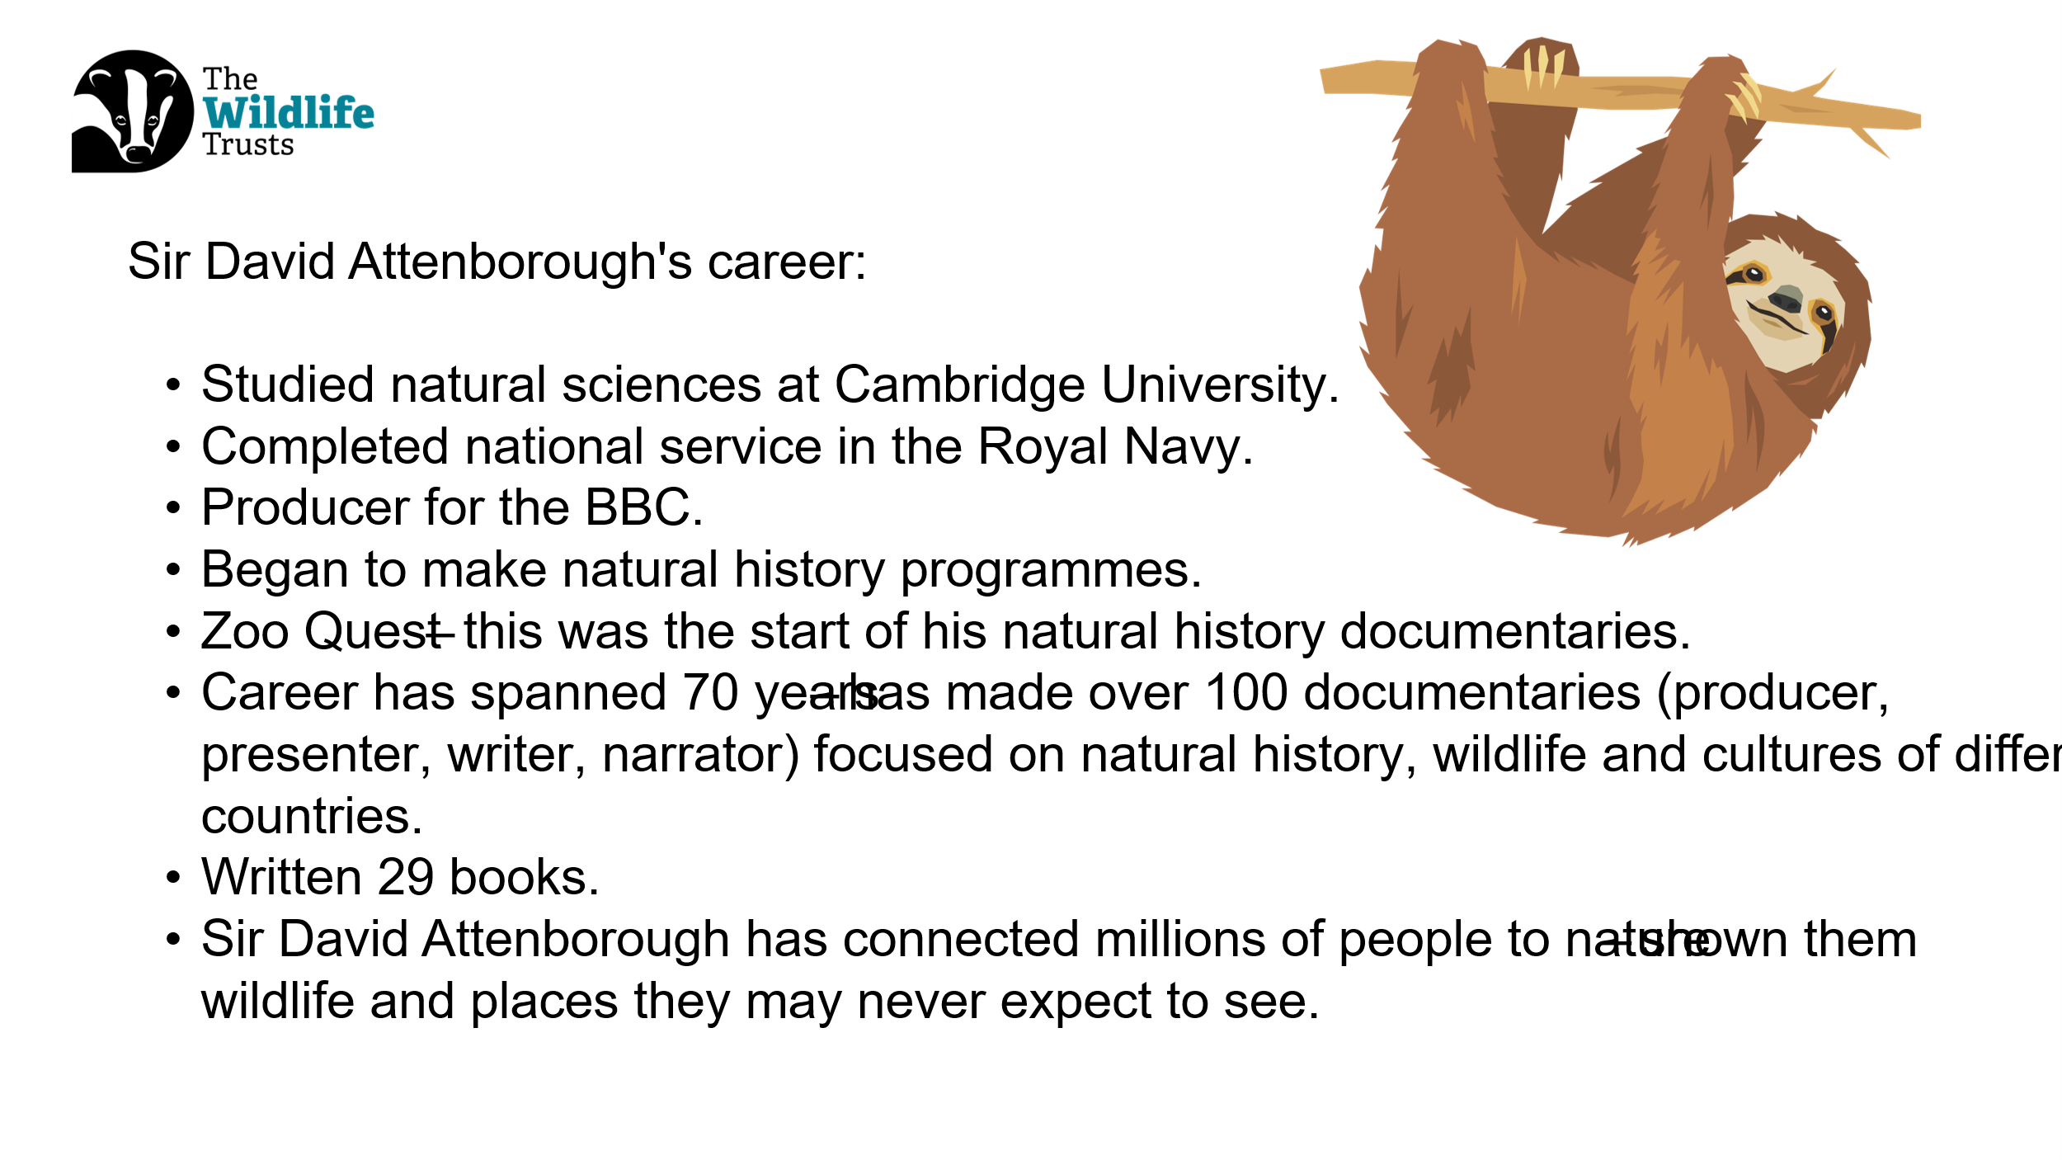
Slide nine: Growing concerns & hope  Script: Over time, Sir David noticed worrying changes in the world. Wild places were shrinking, animals were losing their homes, and pollution was causing the planet to warm.  He realised that if humans didn’t change how we live, it would become harder for both people and animals to survive.  But Sir David also believes there is hope. He believes we can change what happens next — if we act for nature. | Slide nine:  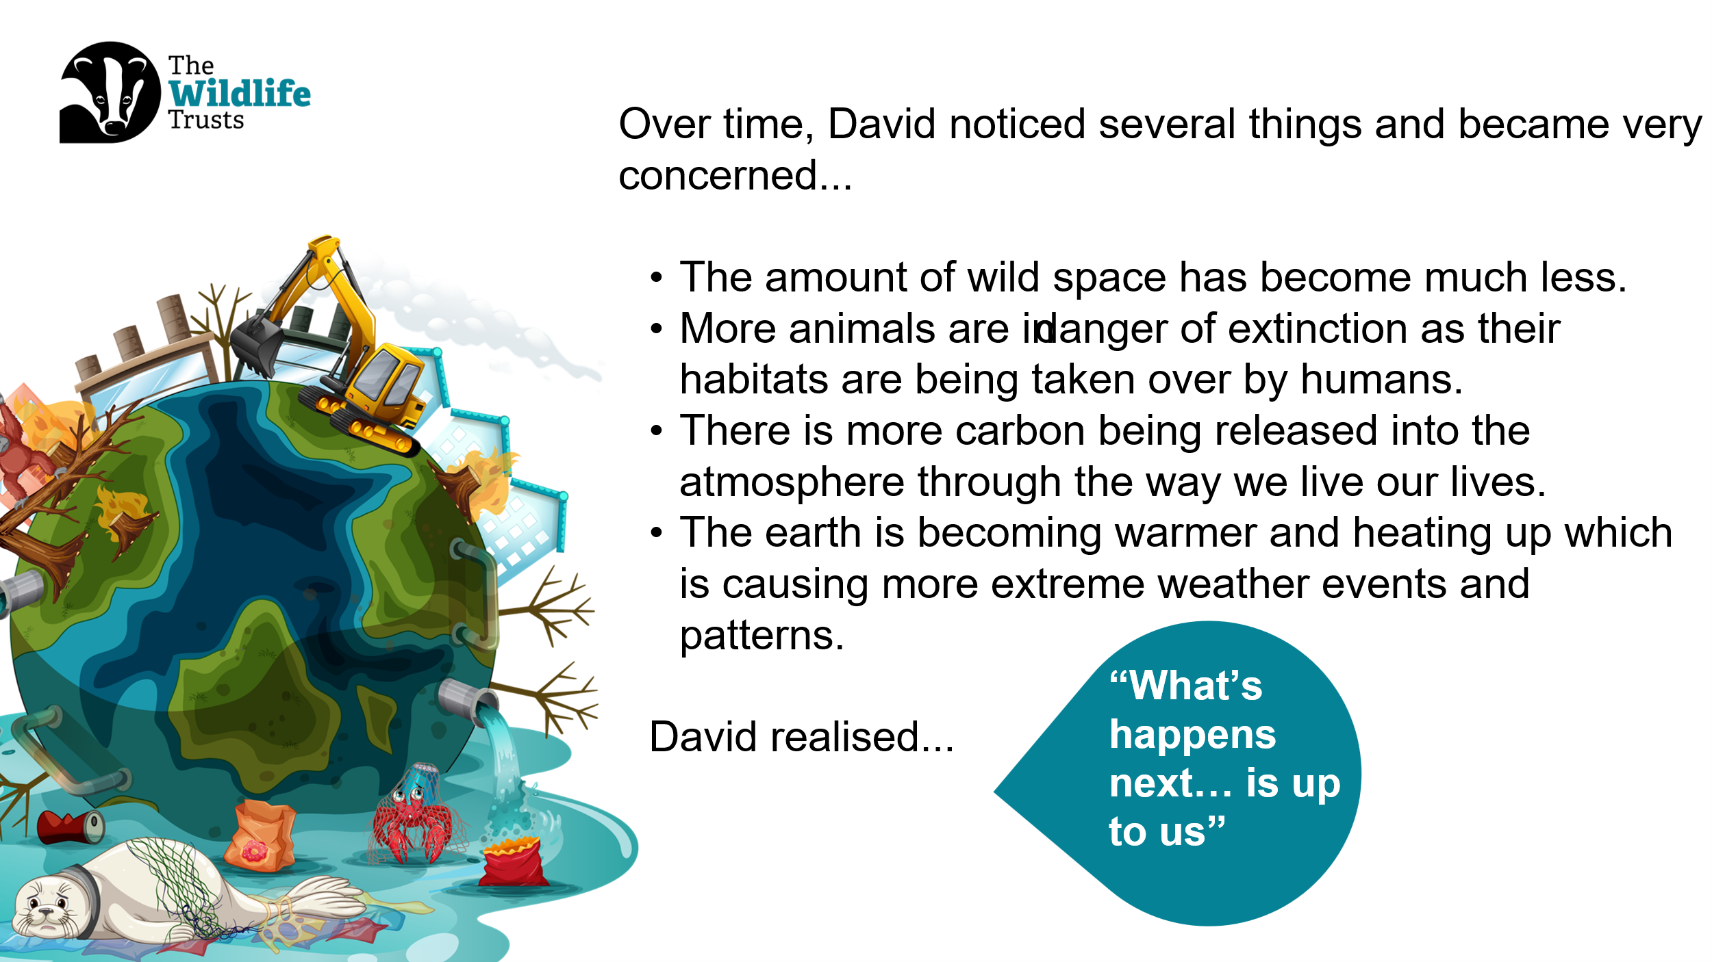
Slide ten: A Life on Our Planet  Script: Sir David made a film, and book called A Life on Our Planet. In it, he explains what changes we need to make so people and nature can live in balance.  [Read selected quotes from the slide and discuss.]  Sir David believes that by working together, we can heal our planet.  So… what can we do? | Slide ten:  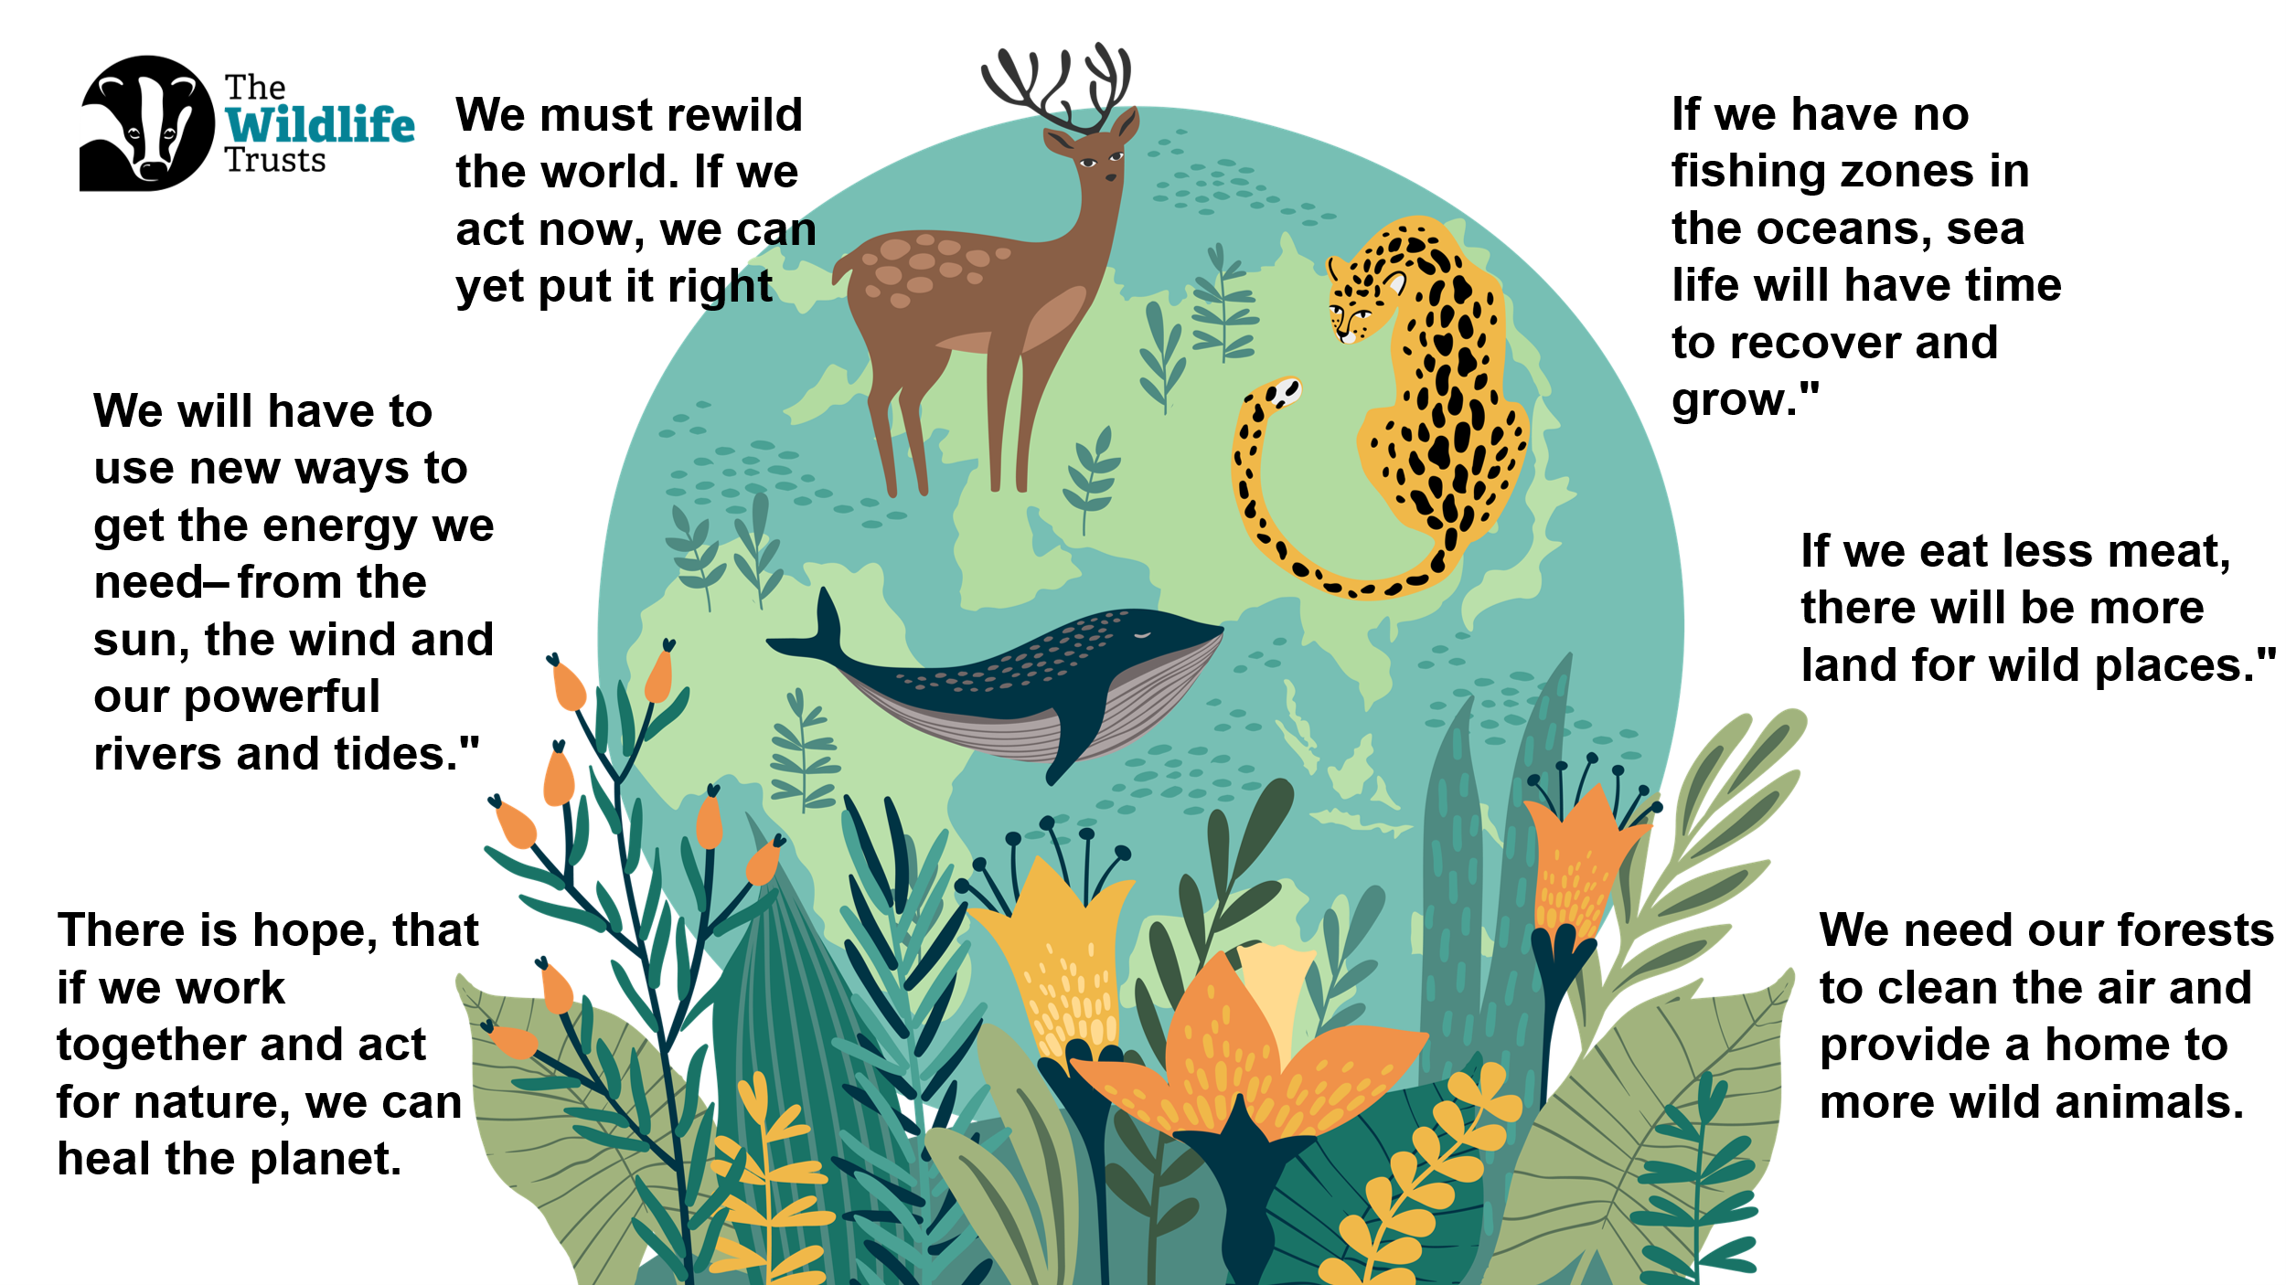
Slide eleven: Green Promise Competition  Script: Manx Wildlife Trust has invited us to take part in their Green Promise competition to celebrate Sir David’s 100th birthday.  Who can tell me what a promise is?  [Take 1–2 responses.]  A Green Promise is a promise to take positive action to help nature.  To enter, we need to create a plan explaining:  - What our promise is  - Why it is important  - How we will keep it.  Our promise must help nature, involve other people, and help us learn and care more about the natural world. | Slide eleven:  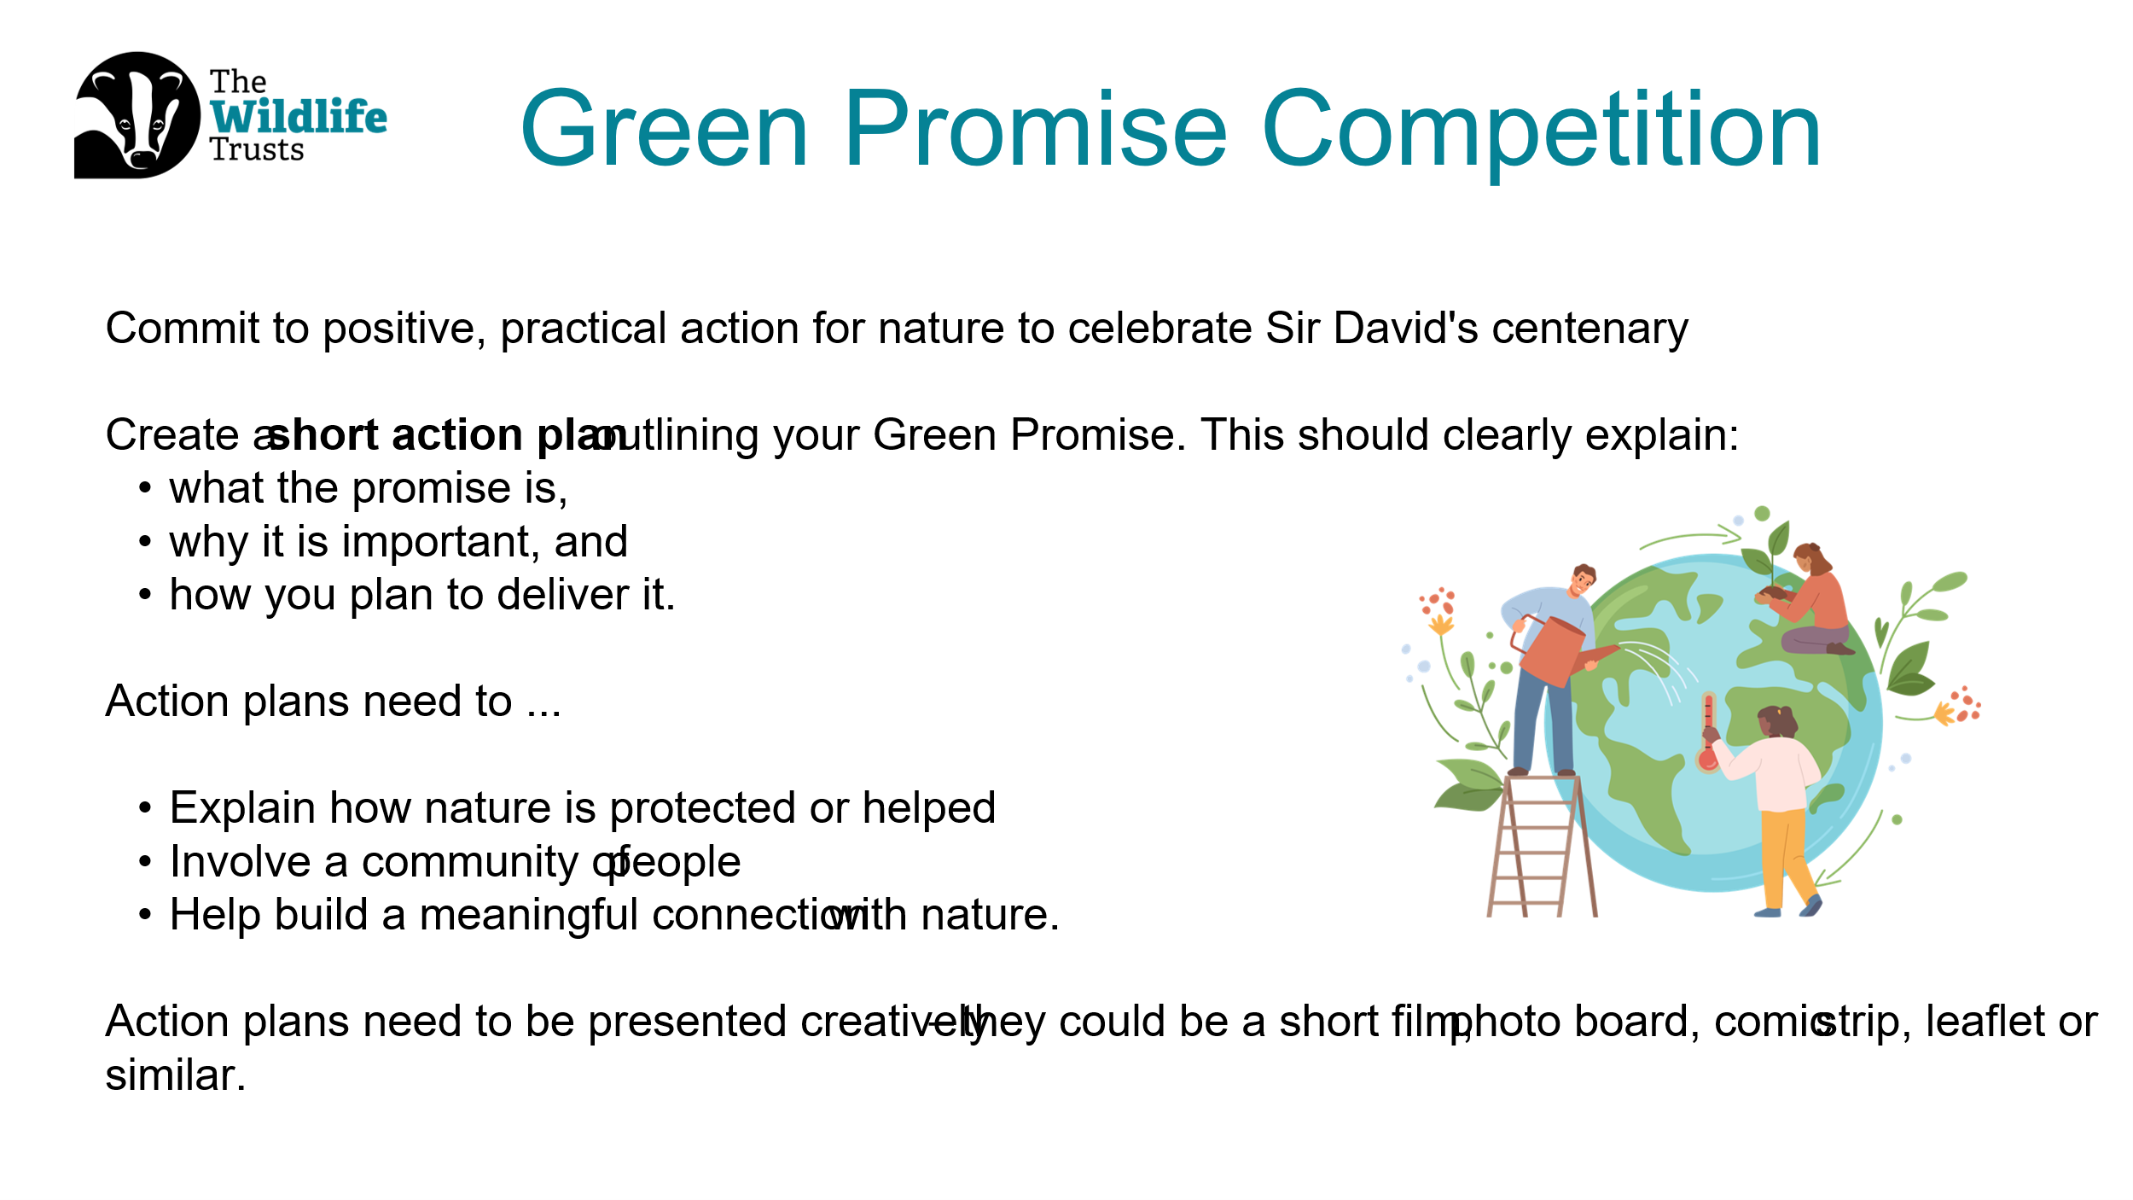
Slide twelve: Judging  Script: Now that we know what a Green Promise is, let’s talk about how your amazing ideas will be judged.  The people at Manx Wildlife Trust want to understand your promise really clearly, so they’ll be looking for a few important things.  First, they want to see if your promise is sustainable.  That means asking: Can this promise keep going for a long time?  For example, is it something you can do again and again, not just once? A good green promise helps nature now and in the future.  Next, they want to know why you chose your conservation action. What made you pick this idea? Is it because you noticed something near your school or home that needs help?  Or maybe it’s something you care about, like animals, plants, or habitats. There’s no wrong answer – they just want to know what matters to you.  Another important thing they are looking for is teamwork.  Your green promise should encourage groups of people to work together. This could be people in your school – like your class, teachers, or school council – and also people outside of school, such as families, neighbours, or the local community.  Working together helps us make an even bigger difference for nature.  They also want to see how your promise helps people learn about and care for nature.  Does your idea teach others something new about wildlife, plants, or the environment? Does it help people understand why nature is important and how we can look after it? Learning is a big step towards caring.  Finally, they will be looking for evidence that you have already started. This means showing that you’ve begun your action plan and are keeping your green promise. You might have photos, posters, notes, videos, or drawings to show what you’ve done so far. Even small steps are important – what matters is that you’ve started.  Remember, all entries need to be sent to Manx Wildlife Trust by the 31st of July 2026. That might feel like a long way away, but it’s a great idea to start as soon as you can. | Slide twelve:  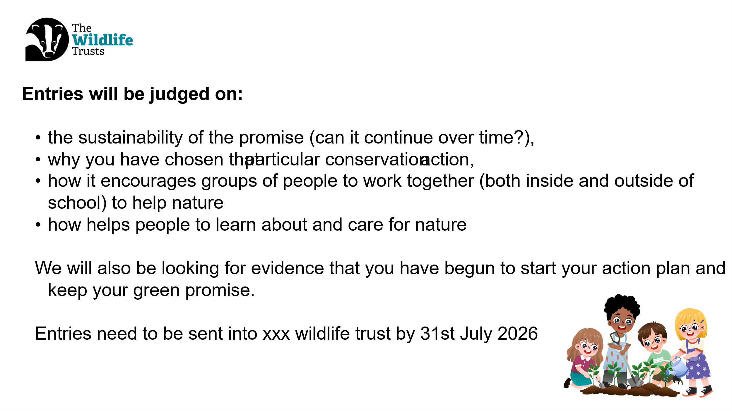
Slide thirteen: Prizes  Script: Now for the exciting part… let’s talk about what you could win! Everyone who takes part is helping nature, which is amazing all by itself. But there are also some fantastic prizes up for grabs!  The first prize is £200 in Muddy Faces vouchers for the school.  That’s a lot of vouchers we could use for outdoor equipment, nature tools, or fun learning resources.  The second prize is £100 in Muddy Faces vouchers. That’s still a brilliant prize to help us keep exploring and enjoying the outdoors.  And the third prize is £50 in Muddy Faces vouchers. A great reward for working hard and helping nature. But that’s not all!  Winning entries from each Wildlife Trust will be put together into a special short presentation. And guess who will get to see it? That’s right — Sir David Attenborough himself!  Your ideas, your promises, and your hard work could be shared with one of the most famous nature lovers in the world. So, remember — every promise you make, every action you take, and every idea you share really matters.  You could win a prize, help nature, and inspire Sir David Attenborough! | Slide thirteen:  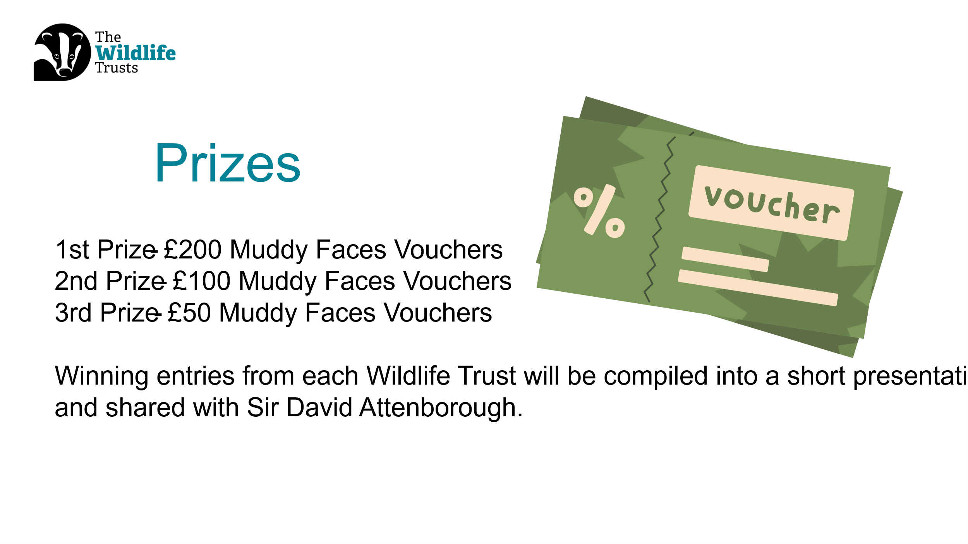
Slide fourteen: Example Action Plan  Script: This is an example of a green promise, which may help us think about our promise. Let’s read through the slide to see if it helps us think more about our promise. [Read through the example on the slide.] | Slide fourteen:  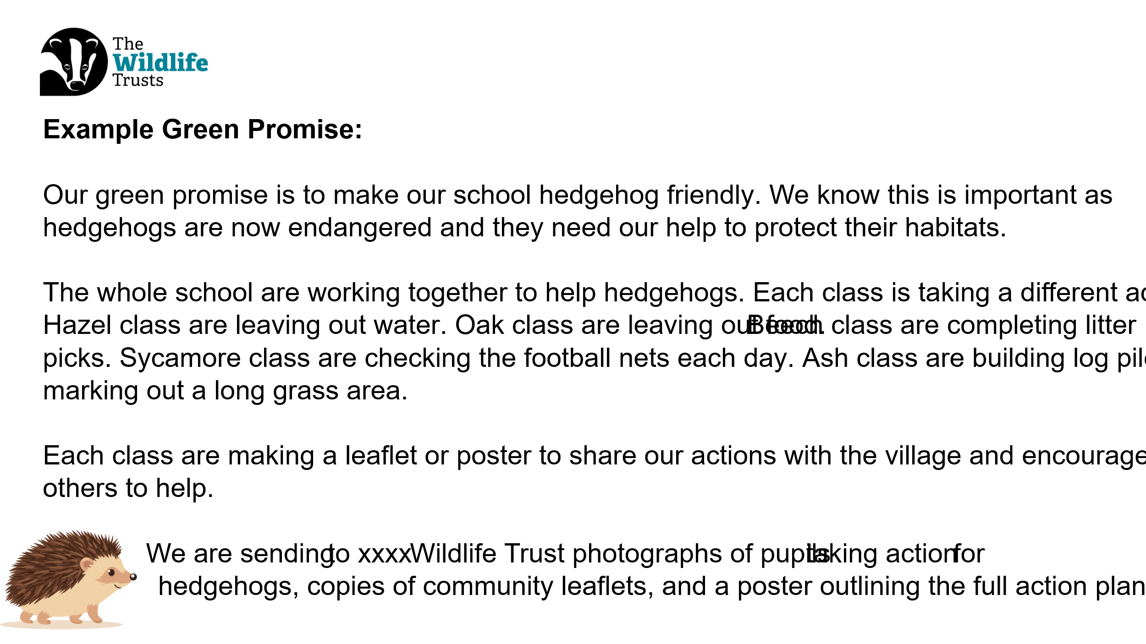
Slide fifteen: Ideas  Script: Now it is our turn to think about a green promise we can make. I am going to give you a little bit of thinking time and then we can collect some ideas. [Allow children some time to think and then ask them to share their ideas. You can record initial ideas on the slide.]  Script: That’s a great start – well done. We will now need to work together in our classes/year groups [adapt as appropriate] to develop our action plans. I can’t wait to see what you come up with. | Slide fifteen:  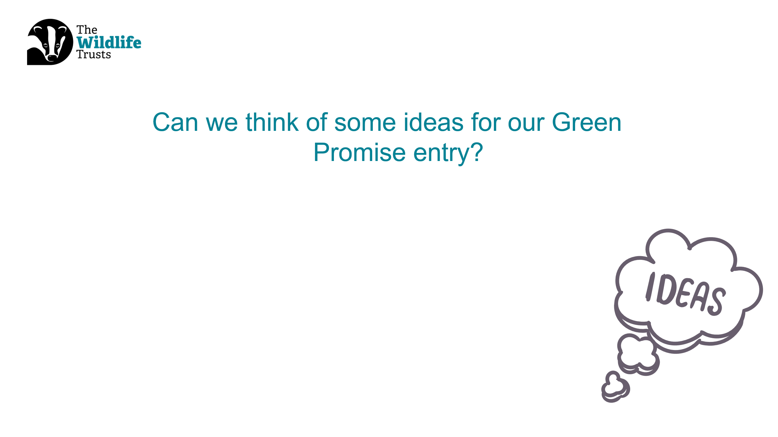
Slide sixteen: Final Reflection  Script: We are now going to come together for a final reflection to finish our assembly. Close your eyes and have some thinking time about Sir David Attenborough’s inspiring life and wisdom as well as what we could do for our green promise. [Read through the reflection on the slide.] | Slide sixteen:  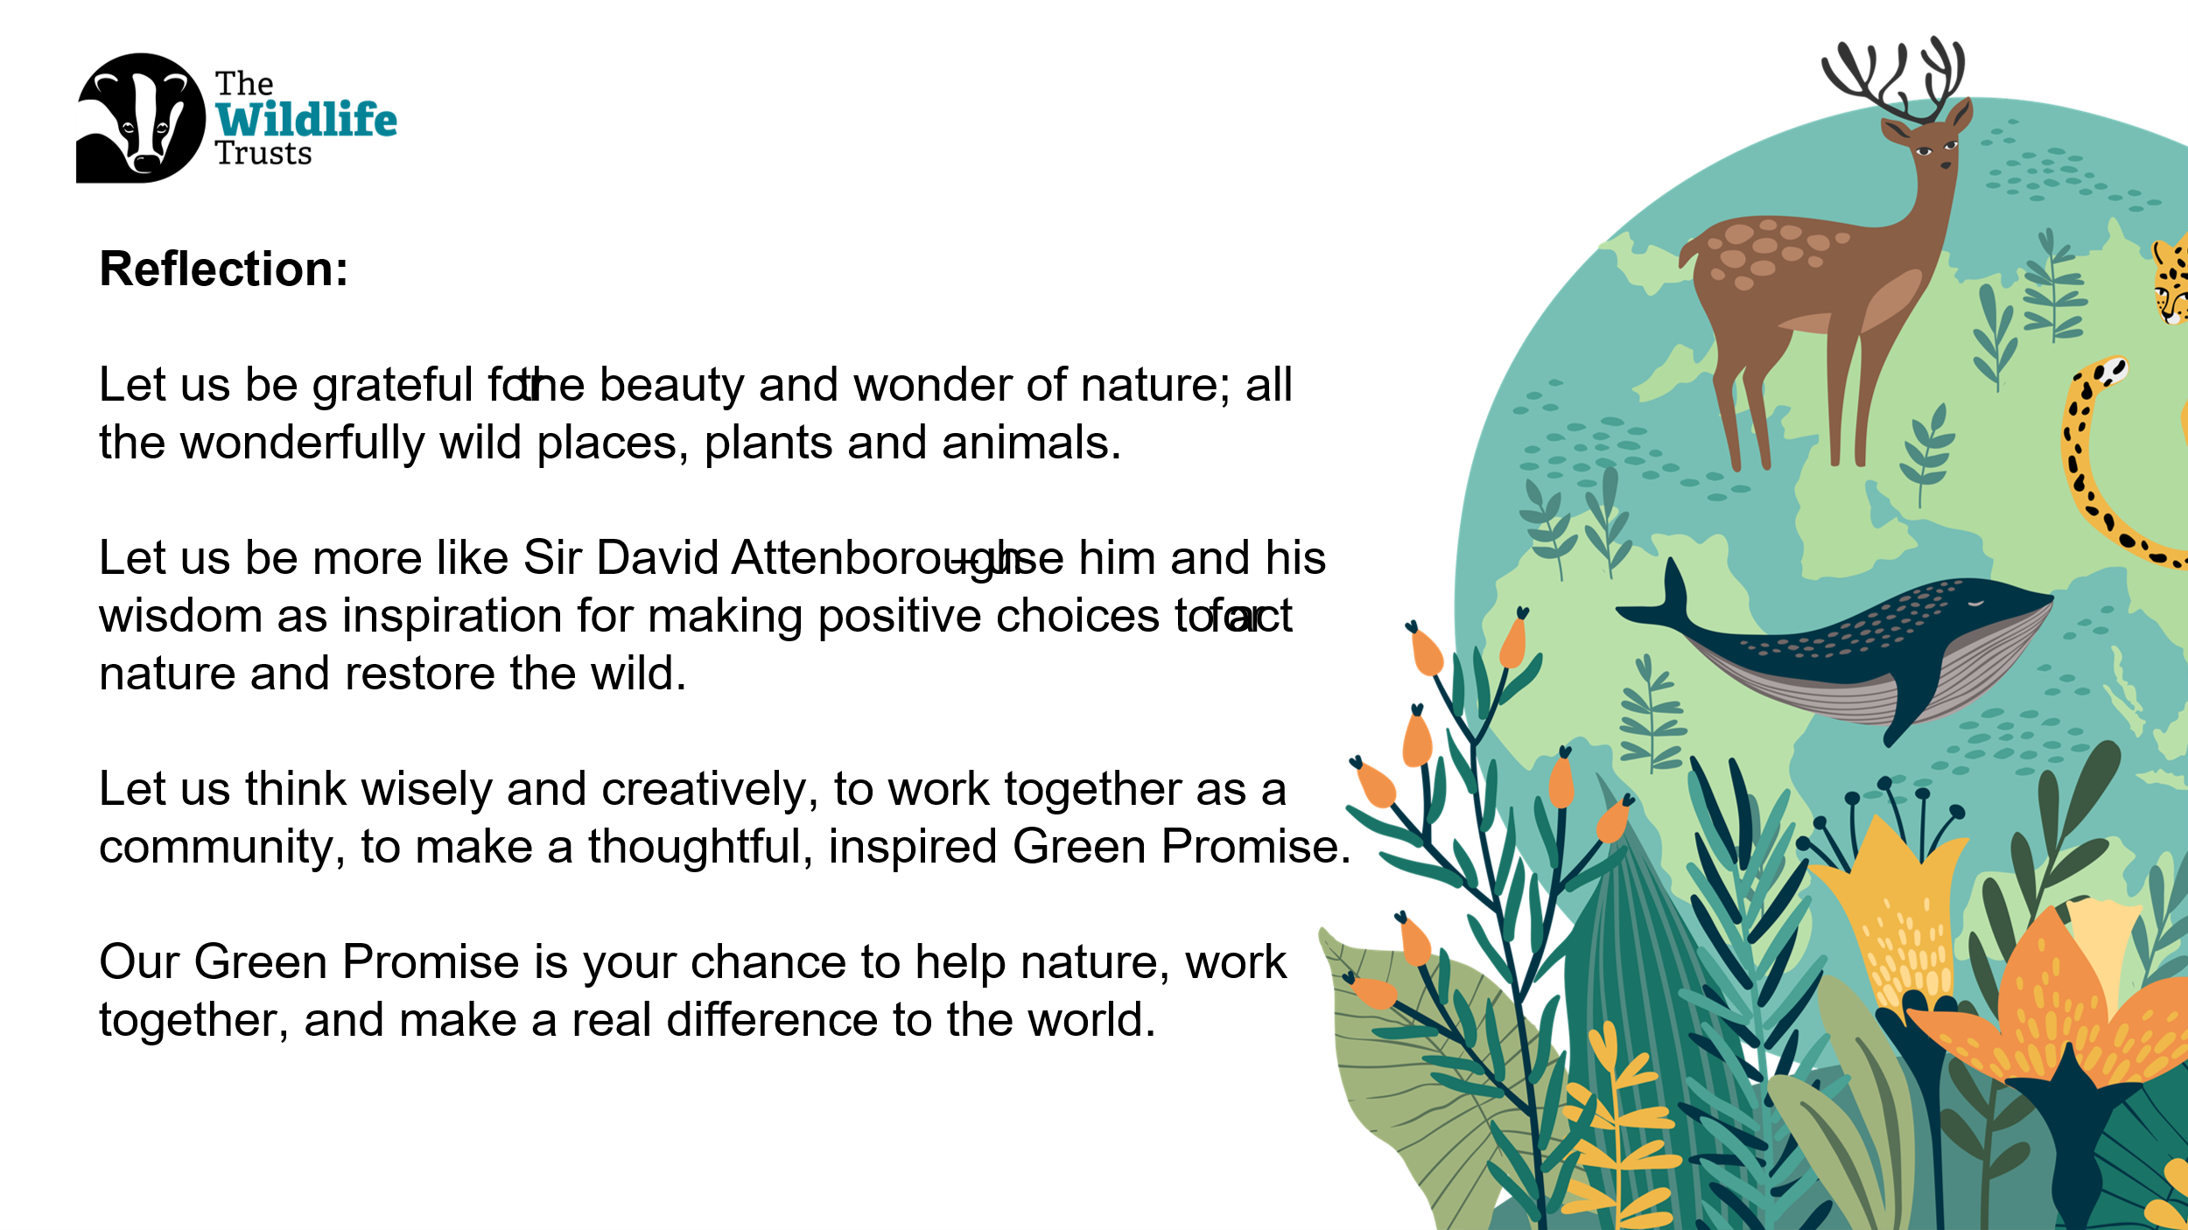
The Wilder school awards was set up by Manx Wildlife Trust to help each school on Island act for nature and make their grounds a little wilder. Find resources on MWT website to know how to build a bird box or set up a hedgehog tunnel. | Slide seventeen:  Wilder School Awards
Let’s Go further | Slide eighteen:  References

